STELLENBOSCH VPN
Download link for Forticlient https://www.forticlient.com/downloads
Connecting to the office using the Forticlient VPN on MiX.Local domain.
- To change the saved username to the new working username, click the gear icon in the right top cornet and select “Edit the selected connection” tab.
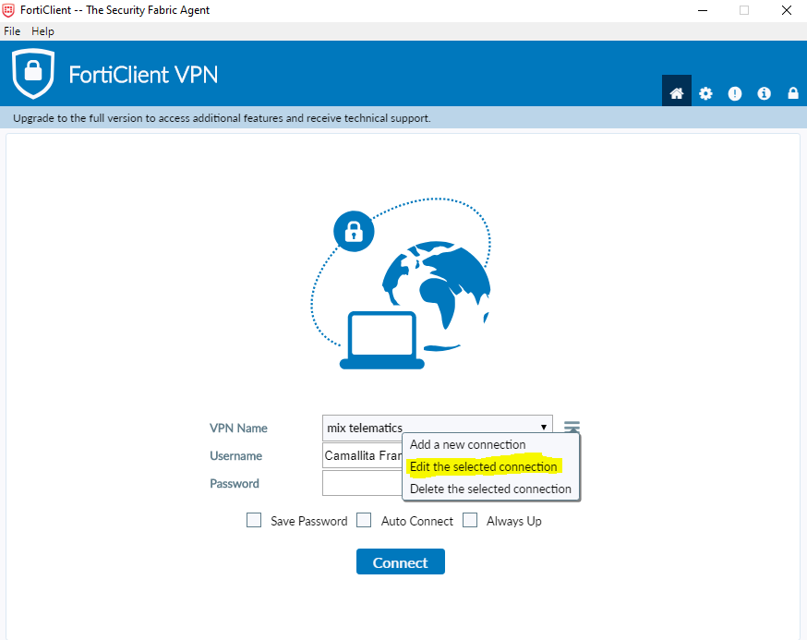
- Ensure the Save Login box Is ticked.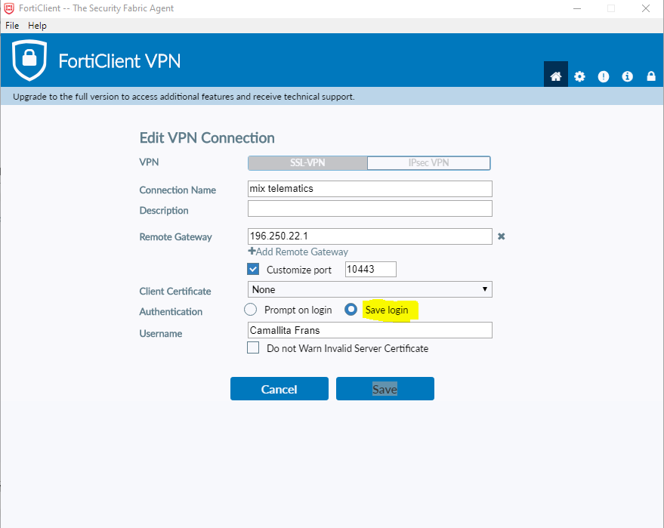

- Change your username to the First Name and Surname as per below.
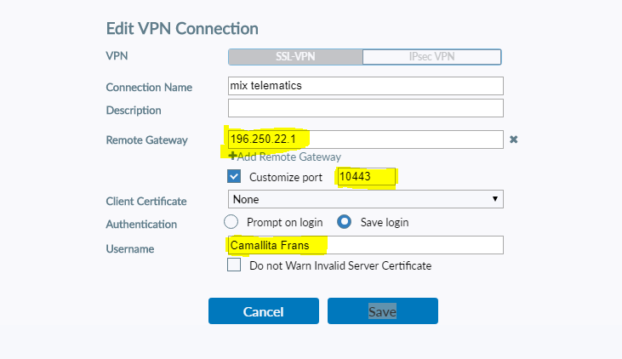
- Ensure that the remote Gateway says stbvpn.mixtelematics.com OR use IP Address
196.250.22.1

- Now on Login screen you will see your new Username is already populated.
Just Enter your password to connect as per normal.
